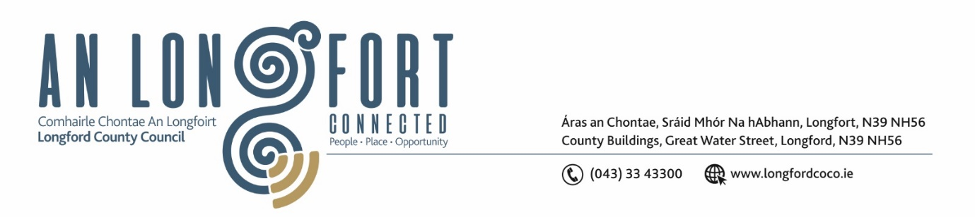

***Please note meeting will be held in the Council Chamber and via Microsoft Teams.***

4 September 2024

**Chuig: Gach Ball don Chomhairle**

A Chomhairleoir,

Iarrtar ort bheith i láthair ag Cruinniú Míosuil Chomhairle Chontae Longfoirt a tionólfar i Seomra na Comhairle, Aras an Chontae, Longford agus via MS Teams are an **Chéadaoin 11 Mean Fomhair 2024 ag 4pm** chun gnó a dhéanamh d’réir an Chláir thíos.

You are requested to attend the Monthly Meeting of Longford County Council to be held in the **Council Chamber and via Microsoft Teams** on **Wednesday, 11 September at 4pm** to transact business, as set out on the Agenda hereunder.

Mise le meas,

**__________________**

***Claire McNabola***

***Meetings Administrator***

**C L Á R**

Prayer before meeting.

1. Confirmation of Minutes:
2. Monthly meeting of Longford County Council held on 10 July 2024 – enclosed
3. Matters Arising.
4. Declaration of Interest by Members.
5. To note Management Report

**5.** To note adopted Minutes of Corporate Policy Group Meeting held on the

1. May 2024 – enclosed.

**6.Community, Library and Cultural Services, Corporate Services**

1. Consideration and adoption of Draft Strategic Policy Committee Scheme 2024 – 2029
2. Consideration of Nominee from Longford County Council to Board of Longford Westmeath Transport CLG
3. Appointment of third member to Longford Enterprise Development Committee Ltd
4. Appointment of fourth member to Longford Community Development Company
5. Consideration of Draft Civic Protocols

**7. Infrastructure, Climate Action and Innovation**

**Notice of Motions Set Out Hereunder:**

1. **Councillor Martin Monaghan**

That Longford County Council look at acquiring a permanent home for Longford Civic Defence. The service that these volunteers provide is an integral part of the running of any event that occurs in our community.

1. **Councillor Uruemu Adejinmi & Councillor Kevin Hussey**

We are calling on Longford County Council to inspect all road signs for obstruction, damage, peeling and/or discolouration and make the necessary repairs / maintenance as needed to improve visibility of signs for road users and safety on our county roads.

1. **Councillor David Cassidy**

I call on Longford County Council to review their policy in relation to the provision of public lighting particularly in the context of road & pedestrian safety.

1. **Councillor Paul Ross**

I call on Longford County Council to write to Coillte and all forestry companies, including Bord na Mona informing them of their legal obligation to maintain their hedgerows along the roads of county Longford in the interest of public safety.

1. **Enterprise and Ukrainian Humanitarian Response**

**Notice of Motions Set Out Hereunder:**

1. **Councillor Seamus Butler**

I call on Longford County Council to provide an update on a potential site for the IDA Advance facility for Longford and I also request a presentation by IDA personnel for the October meeting of Longford County Council

1. **Finance and Information Technology**
2. To note draft minutes from the April Meeting of the Governance SPC held on 16 April 2024
3. To consider the Local Property Tax Variation in accordance with the provisions of Section 20 of the Finance (Local Property Tax) Act 2012
4. **Housing, Planning, Regeneration & Capital Projects**
5. To note planning applications received
6. **Correspondence**
7. Correspondence received from Bus Eireann
8. Correspondence received from HSE regarding St. Christophers
9. Correspondence received from HSE regarding the retention of Nurses.
10. **General**
11. **Training Approval**
12. **Votes of Sympathy**